Weather Forecasting Using Autoregressive Models

In this work we are employing Autoregressive models to forecast weather and then compare its performance with SVM algorithm and in both algorithm propose Autoregressive model is giving less MSE (mean square error) and MAE(mean absolute error) error. MSE and MAE refers to difference between true values and predicted values so the lower the MSE the better is the model.

To train both algorithms we have used Weather Forecast dataset from KAGGLE repository and can be download from below link

<https://www.kaggle.com/code/milangabriel/weather-data-analysis/input>

In below screen we are displaying some values from the dataset and using this dataset we trained models to forecast temperature which is main value to know about the weather

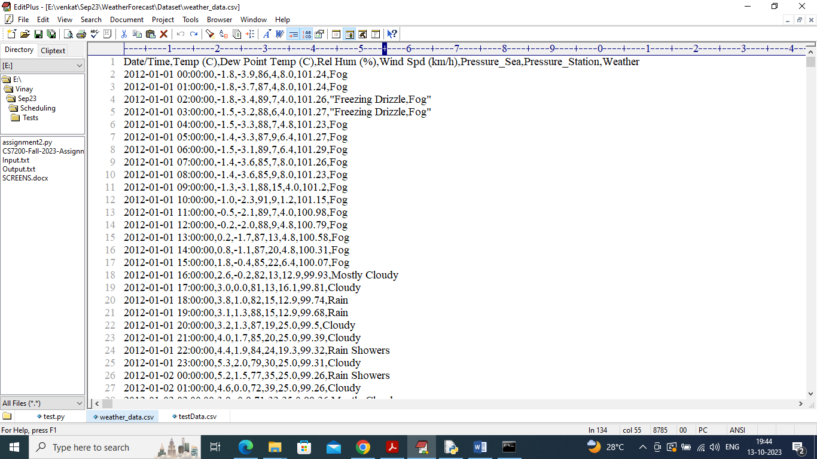

In above dataset screen first row contains dataset column names and remaining rows contains dataset values and by using above dataset will train and test both SVM and Autoregressive models.

To implement this project we have designed following modules

1. Upload Weather Dataset: using this module we will upload dataset to application and then display loaded dataset values
2. Pre-process Dataset: using this module we will convert date into year, month, day format and then normalize all values and then replace missing values with mean and then convert entire dataset into numeric format
3. Split Dataset Train & Test: using this module split dataset into train and test where application will be using 80% dataset for training and 20% for testing
4. Train SVM Algorithm: using this module we will train existing SVM algorithm on training data and then perform prediction on test data and then calculate MSE between original temperature and predicted temperature
5. Train Autoregressive Models: using this module we will train propose Autoregressive algorithm on training data and then perform prediction on test data and then calculate MSE between original temperature and predicted temperature
6. Comparison Graph: using this module we will plot comparison graph between SVM and Autoregressive models
7. Predict Weather from Test Data: using this module we will upload test data and then Autoregressive model will predict weather temperature from test data

SCREEN SHOTS

To run project double click on ‘run.bat’ file to get below screen

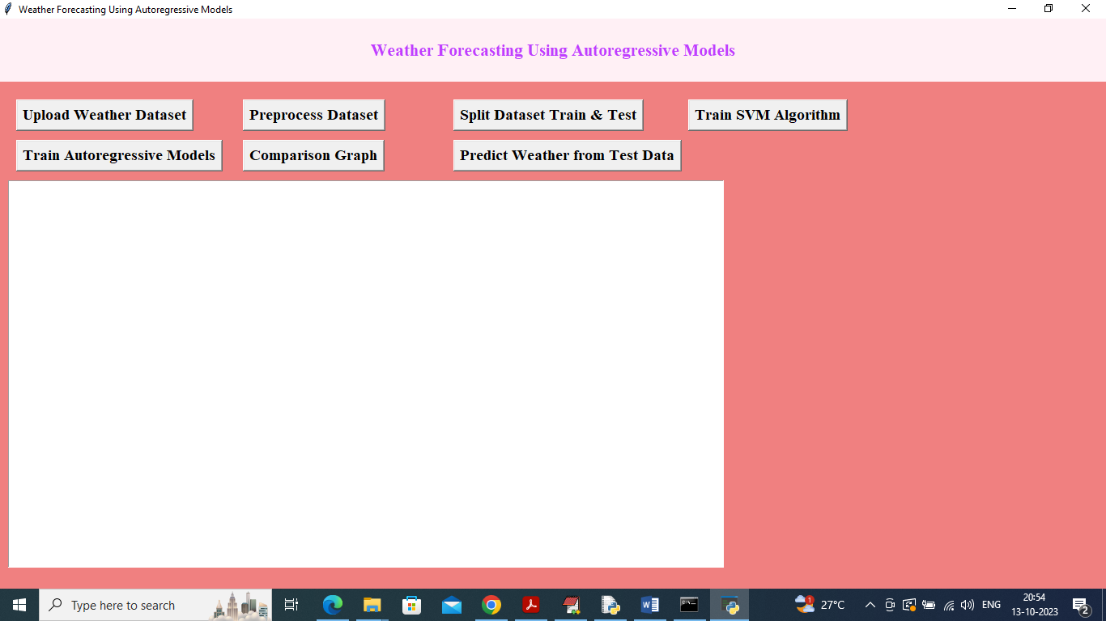

In above screen click on ‘Upload Weather Dataset’ button to upload dataset to application and get below output

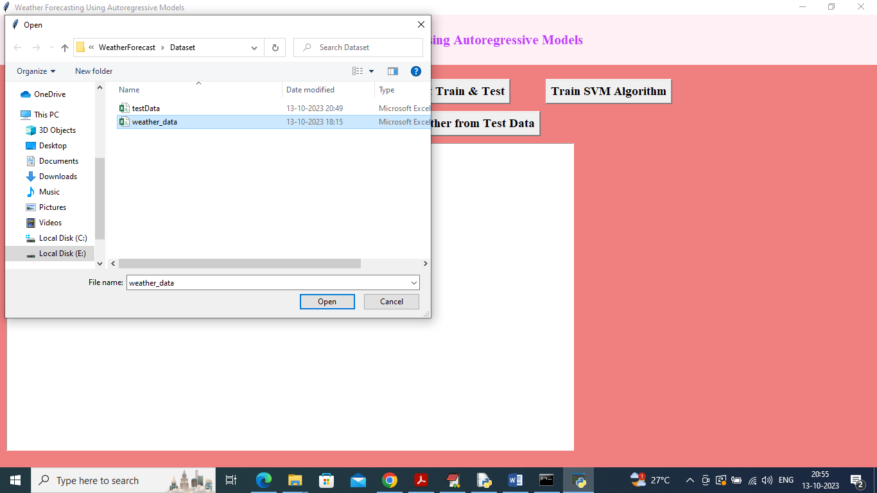

In above screen selecting and uploading ‘Weather Dataset’ and then click on ‘Open’ button to load dataset and get below output

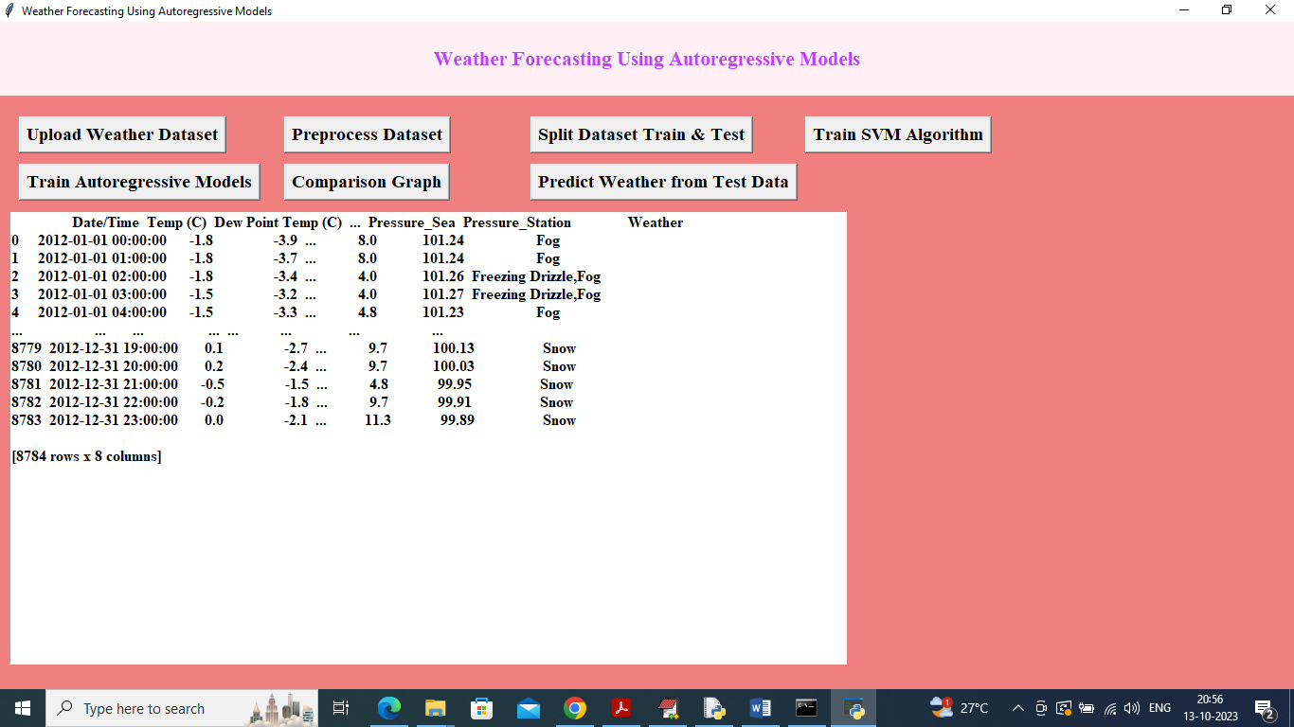

In above screen dataset loaded and in dataset we have numeric and non-numeric values and now click on ‘Pre-process Dataset’ button to convert entire dataset into numeric and get below output

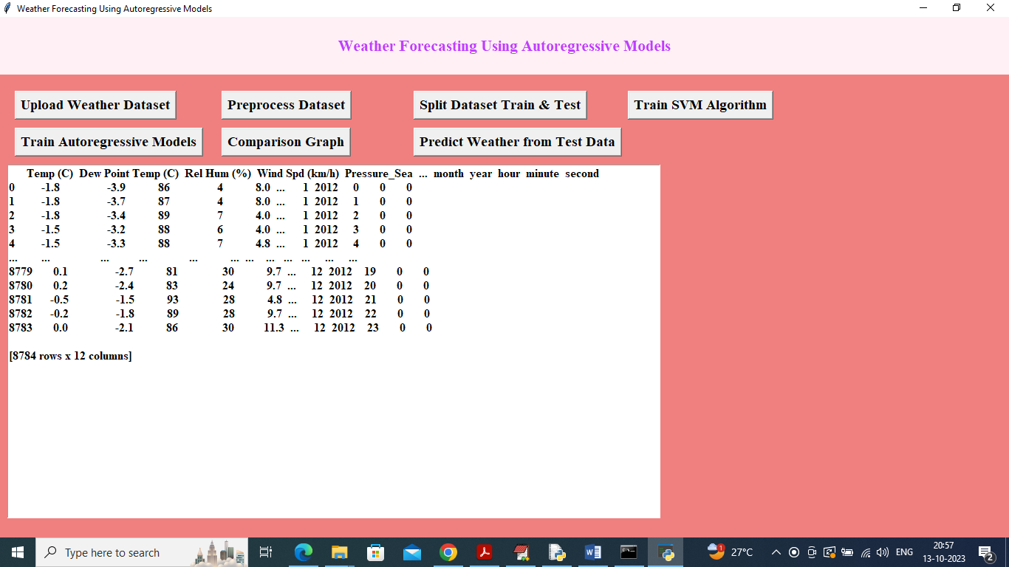

In above screen dataset converted to numeric format and then click on ‘Split dataset Train & Test’ button to split dataset into train and test and then will get below output

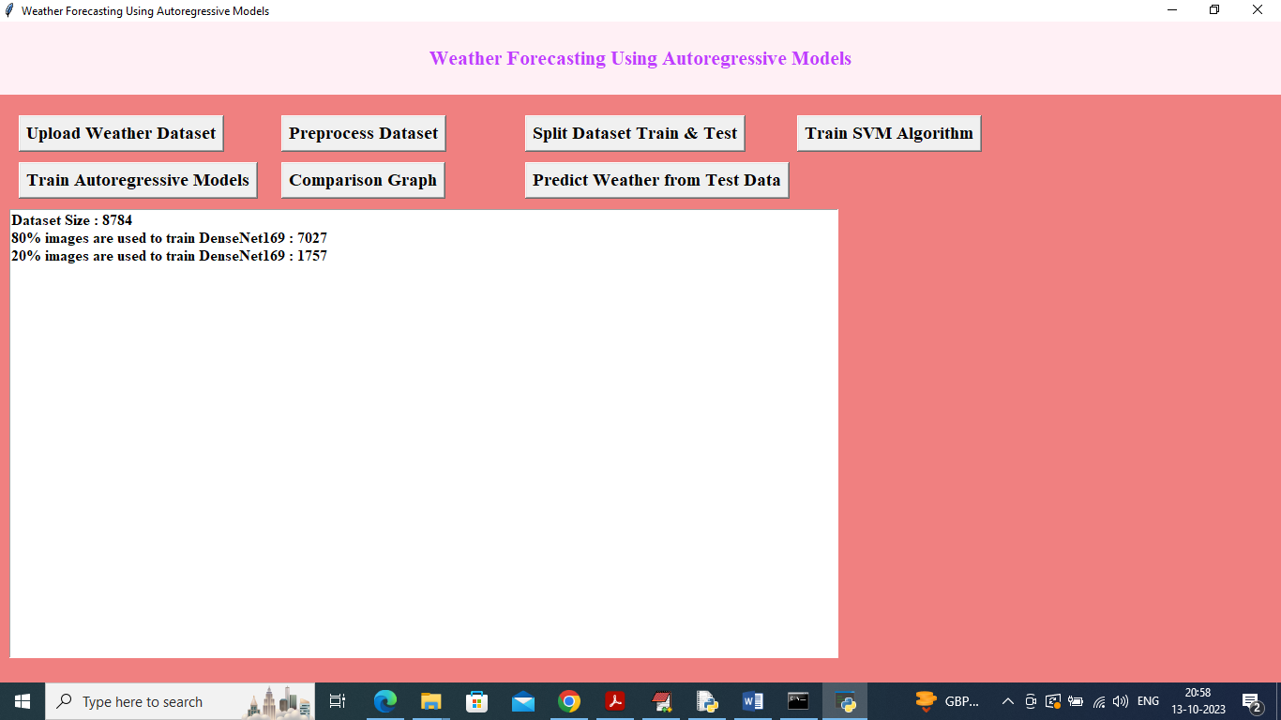

In above screen we can see dataset size and then train and test size and then click on ‘Train SVM Algorithm’ button to get below output

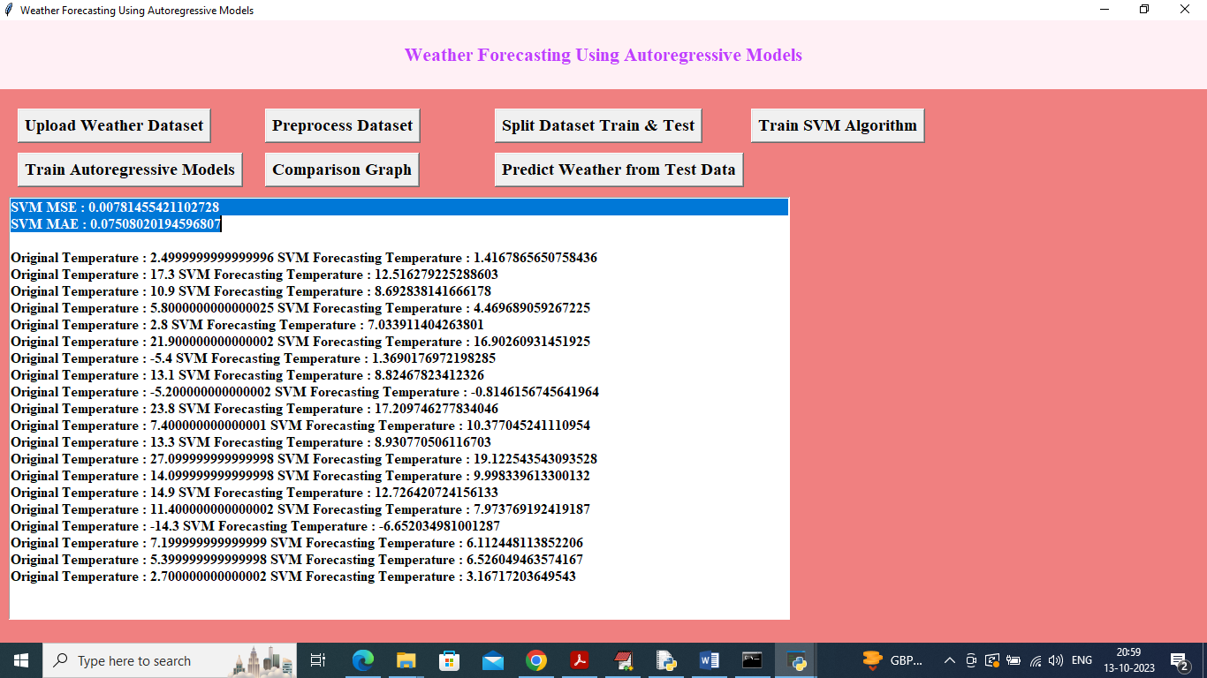

In above screen in first two lines we can see SVM MSE and MAE values and then in next line we can see test data temperature and SVM predicted temperature and by seeing both values we can see there is not much difference between original and predicted values and can say SVM is little accurate in forecasting and below is the SVM prediction graph

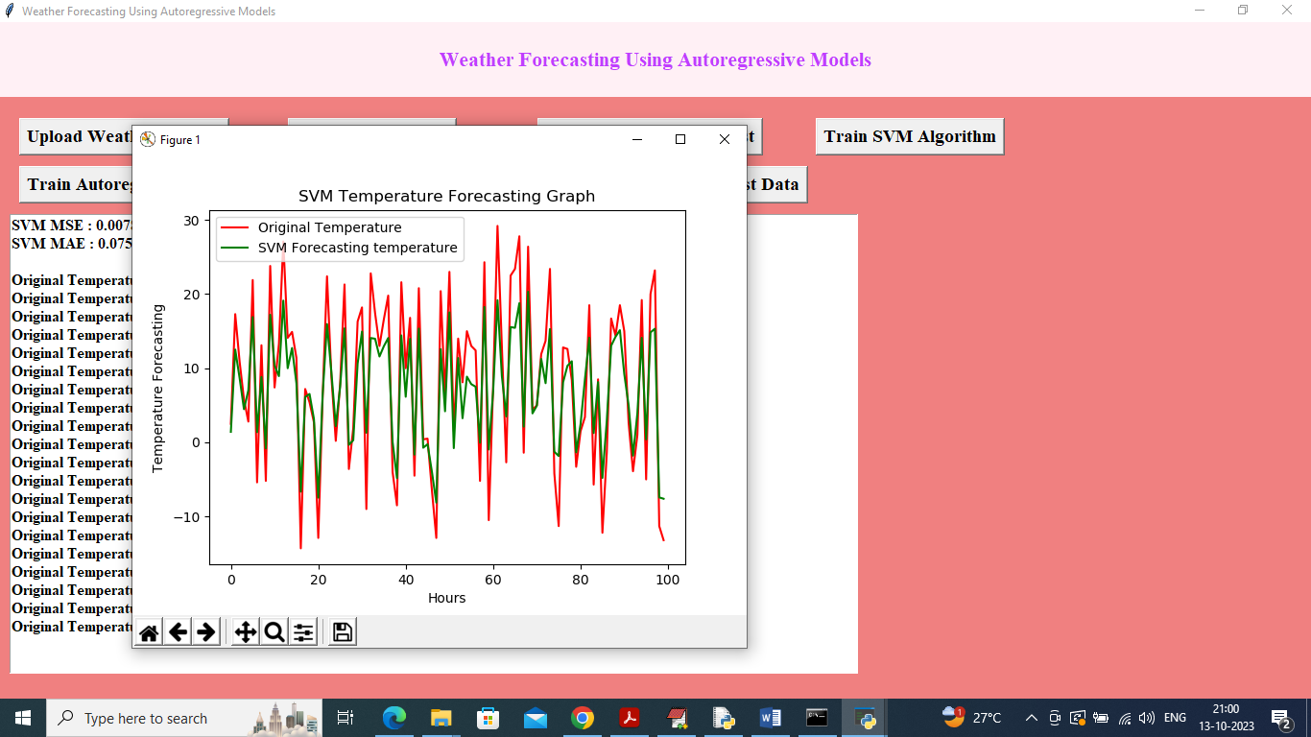

In above SVM forecast graph x-axis represents HOURS and y-axis represents weather temperature and in graph red line represents True temperature and green line represents SVM forecast temperature and in above graph both lines are overlapping with some gaps so SVM is not much accurate and now close above graph and then click on ‘Train Autoregressive Models’ button to train model

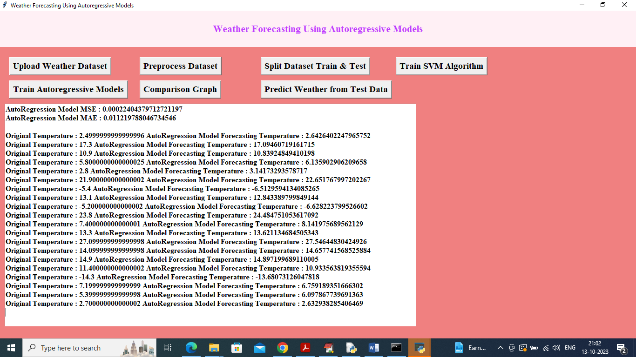

In above screen in first two lines we can see Autoregressive MSE and MAE error values which are lower than SVM and can see predicted values also and below is the Autoregressive forecast graph

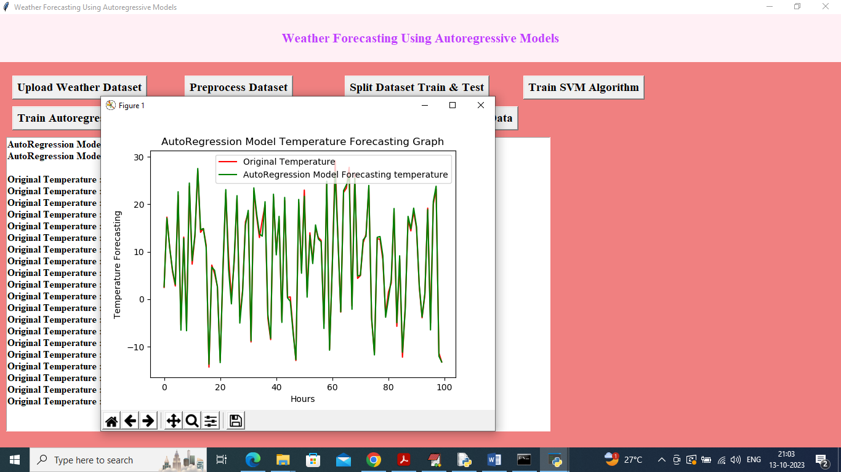

In above graph both original and Autoregressive forecast values are overlapping and we can say Autoregressive is accurate more than 99% as above graph is fully overlapping without gap and now close above graph and then click on ‘Comparison Graph' button to get below graph

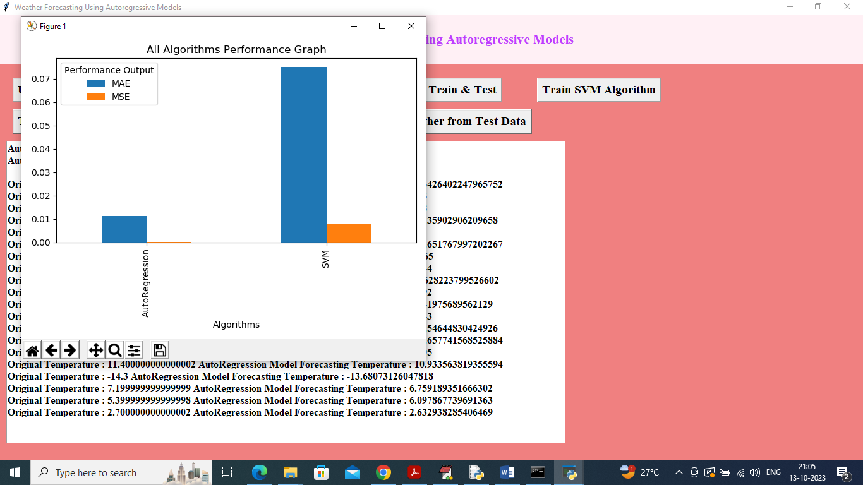

In above graph x-axis represents algorithm names and y-axis represents MSE and MAE values in different colour bars and in both algorithms Autoregressive got less MSE and MAE error values so Autoregressive is best in prediction and now close above graph and then click on ‘Predict Weather from Test Data’ button to upload test data and predict weather temperature

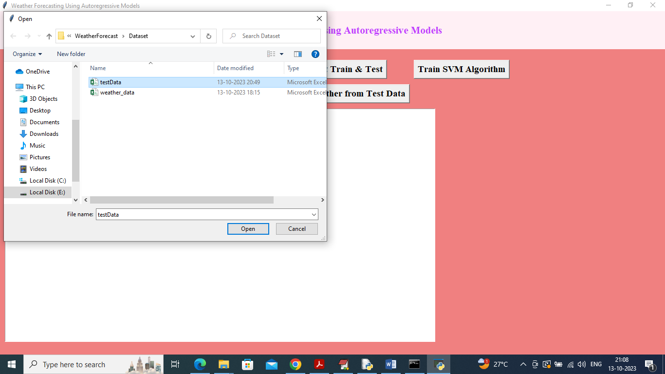

In above screen selecting and uploading ‘test data’ and then click on ‘Open’ button to get below weather prediction

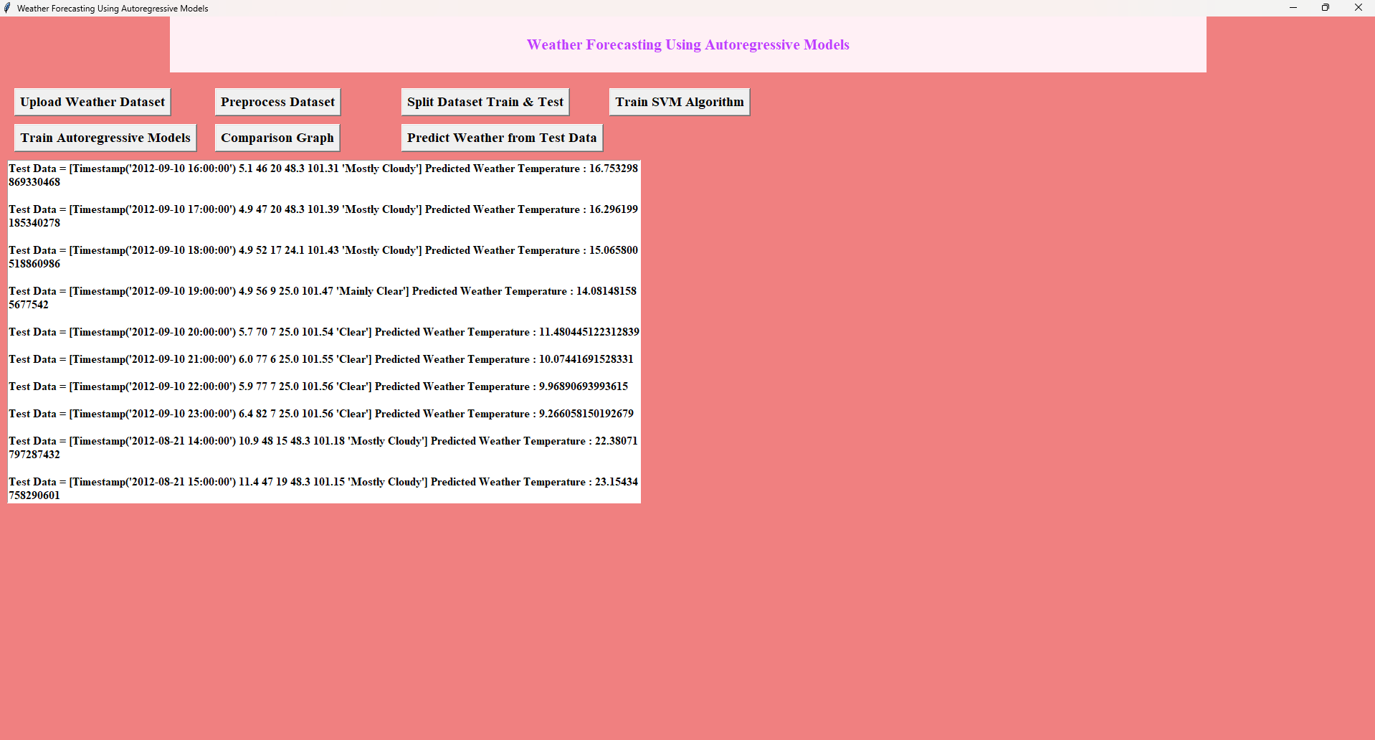

In above screen in square bracket we can see TEST data values and in last after : symbol we can see predicted weather temperature and based on temperature we can say weather will be HOT or COLD.